1.What is UPSTREAM in power bi: --
In Power BI, upstream refers to the data sources and processes that feed data into a particular dataflow or report. Essentially, it's the origin of the data before it gets transformed and used in your Power BI reports and dashboards1.
(Power bi to another data – upstream)
For example, if you have a dataflow that pulls data from an Excel file and a SQL database, those sources are considered upstream. Understanding the upstream data helps you trace the data lineage and ensure the accuracy and integrity of your reports1.
what is downstram in power bi
In Power BI, downstream refers to the data flows, reports, dashboards, and other analyses that use or are derived from a particular data source or dataflow. Essentially, downstream elements are the outputs and final products that are built using the transformed data1.
(server to power bi -- downstream)
For example, if you have a dataflow that processes sales data, the reports and dashboards that visualize this data are considered downstream. Understanding the downstream helps you see how the data is being utilized and ensures that changes in upstream data sources are accurately reflected in the final outputs1.

2.what is report in power bi: --
A report in Power BI is a collection of visualizations, such as charts, graphs, maps, and tables, that display data insights in an interactive and visually appealing way. Reports help users analyze and understand their data by presenting it in a structured and meaningful manner.
Key features of Power BI reports include:
- Interactive Visuals: Users can click on different elements to filter and drill down into the data.
- Customizable Layouts: Reports can be designed to fit specific needs, with a variety of visual types and customization options.
- Data Connectivity: Reports can connect to various data sources, including Excel, SQL databases, and online services.
- Real-time Data: Reports can display real-time data and automatically refresh to show the latest information.
Reports are typically created using Power BI Desktop and then published to the Power BI Service for sharing and collaboration.

Steps to Create a Report in Power BI
- Open Power BI Desktop:
  - Download and install Power BI Desktop from the Power BI website.
  - Launch Power BI Desktop and start a new report.
- Connect to Data Sources:
  - Click on "Get Data" to connect to various data sources such as Excel, SQL Server, SharePoint, Azure, and more.
  - Load the data into Power BI Desktop.
- Prepare and Transform Data:
  - Use the Power Query Editor to clean, transform, and shape the data as needed. Common transformations include filtering rows, removing columns, renaming columns, and changing data types.
- Create Visualizations:
  - Drag and drop fields from the data model onto the report canvas to create visualizations such as charts, graphs, tables, and maps.
  - Customize visualizations by using the formatting options available in the Visualizations pane.
  - Examples of common visualizations include bar charts, line charts, pie charts, scatter plots, and maps.
- Add Interactivity:
  - Add slicers, filters, and drill-through functionality to make the report interactive and user-friendly.
  - Use bookmarks and buttons to create navigation and enhance the user experience.
- Design the Report Layout:
  - Arrange visualizations on the report canvas to create a coherent and visually appealing layout.
  - Use themes and color schemes to maintain a consistent look and feel.
- Create Multiple Pages:
  - If needed, add multiple pages to the report to cover different aspects of the data or to present detailed analyses.
- Add Data Insights:
  - Use Power BI's AI features like Q&A, key influencers, and decomposition trees to gain deeper insights into the data.
- Publish the Report:
  - Click on "Publish" to publish the report to the Power BI Service (app.powerbi.com).
  - Choose the workspace where you want to publish the report.
- Share and Collaborate:
  - Share the report with colleagues and stakeholders by providing access through the Power BI Service.
  - Embed the report in SharePoint, Teams, or other applications for wider distribution.

What is power bi admin: --
Power BI Administrator Responsibilities:
- Workspace Management: Create, manage, and monitor workspaces, ensuring proper access and security.
- Capacity Management: Oversee the allocation and utilization of Premium capacities, optimizing performance.
- Data Governance: Ensure data compliance, security, and governance policies are enforced across Power BI content.
- Tenant Settings: Configure and manage Power BI tenant settings, controlling features and functionality available to users.
- User Management: Assign roles and permissions, manage user licenses, and monitor user activity within Power BI.
- Content Monitoring: Monitor and audit Power BI reports, dashboards, and datasets for performance and usage.
- Support and Troubleshooting: Provide support to users, troubleshoot issues, and liaise with Microsoft support if needed.
- Compliance and Auditing: Ensure compliance with data protection regulations and perform regular audits on data access and usage.
Microsoft Administrator Responsibilities:
- User Management: Create, manage, and delete user accounts, groups, and organizational units. Assign licenses and roles to users.
- Security and Compliance: Implement security policies, manage access controls, monitor security alerts, and ensure compliance with data protection regulations.
- Application Management: Manage enterprise applications, configure app permissions, and enable single sign-on (SSO) for secure access.
- Device Management: Oversee device management, including enrolling devices, applying security policies, and ensuring compliance for devices accessing the organization’s data.
- Azure Services Management: Manage Azure resources, subscriptions, and service configurations. Monitor Azure usage and performance.
- Office 365 Administration: Administer Office 365 services (e.g., Exchange Online, SharePoint Online, Teams), including setting up and managing these services for the organization.
- Identity and Access Management: Configure and manage identity and access management settings, including multi-factor authentication (MFA), conditional access policies, and identity protection.
- Support and Troubleshooting: Provide support to users, troubleshoot issues, and work with Microsoft support to resolve complex problems.

3.Difference between power bi admin role and Microsoft admin role: --
The Power BI Administrator role is specific to managing Power BI resources within an organization. This includes tasks like setting up and managing workspaces, dataflows, datasets, and permissions related to Power BI content2.
On the other hand, a Microsoft Administrator (often referred to as an Azure Active Directory (AAD) Administrator or Global Administrator) has a broader scope of responsibilities that extend across the entire Microsoft ecosystem1. This role includes managing user accounts, licenses, security policies, and other administrative tasks across services like Office 365, Azure, and more1.
In summary:
- Power BI Administrator: Focuses on Power BI-specific tasks and settings1.
- Microsoft Administrator: Manages a wide range of administrative tasks across various Microsoft services

Connecting Power BI with various Microsoft services can greatly enhance your data analysis and reporting capabilities. Here are some key integrations between Power BI and Microsoft services:
4.Connect between power bi and Microsoft : --
Power BI and Microsoft 365 (Office 365):
  - SharePoint: Embed Power BI reports in SharePoint Online for easy access and sharing within your organization.
  - Excel: Import data from Excel files into Power BI and analyze Excel data using Power BI visualizations.
  - Teams: Embed Power BI reports and dashboards in Microsoft Teams for collaborative analysis.
- Power BI and Azure:
  - Azure SQL Database: Connect Power BI to Azure SQL Database to visualize and analyze your data.
  - Azure Data Lake Storage: Use Power BI to access and analyze data stored in Azure Data Lake.
  - Azure Synapse Analytics: Integrate Power BI with Azure Synapse for advanced analytics and big data processing.
- Power BI and Microsoft Dynamics 365:
  - Dynamics 365: Connect Power BI to Dynamics 365 (e.g., Sales, Finance, Operations) to analyze business data and gain insights.
- Power BI and Microsoft Power Platform:
  - Power Apps: Create custom apps that leverage Power BI reports and data visualizations.
  - Power Automate: Automate workflows and integrate Power BI with other services using Power Automate (formerly Microsoft Flow).
By leveraging these integrations, you can create a seamless data ecosystem within the Microsoft environment, making it easier to access, analyze, and share insights across your organization.

Create a data flows in power bi: --
Steps to Connect to a Dataflow in Power BI Desktop:
- Create a Dataflow in Power BI Service:
  - As mentioned, first, you need to create a Dataflow in the Power BI Service.
  - Go to the Power BI Service, create a dataflow in your desired workspace, and define your data transformations and entities using Power Query.
- Access the Dataflow in Power BI Desktop:
  - Once you have your dataflow created in the Power BI Service, open Power BI Desktop.
  - Go to the Home tab, click on Get Data, and select Power BI Dataflows from the list of options.
- Connect to Your Power BI Dataflow:
  - A dialog will appear prompting you to sign in to your Power BI account.
  - After signing in, you'll be able to see a list of available workspaces and dataflows that you've created in Power BI Service.
  - Select the workspace that contains the dataflow you want to use.
  - Choose the specific dataflow and the entities (tables) within the dataflow that you want to load into Power BI Desktop.
- Load the Data:
  - After selecting the entities, click Load to load the data into Power BI Desktop, or click Transform Data if you want to apply any additional transformations using the Power Query Editor.
- Use the Data in Reports:
  - After loading the dataflow entities into Power BI Desktop, you can now use them to create visuals, build reports, and perform further analysis.
Important Notes:
- Dataflows in Power BI Service: As of now, dataflows are a feature of the Power BI Service. You need to create them in the Power BI Service first before you can access and use them in Power BI Desktop.
- Power BI Pro or Premium: Accessing and using Power BI dataflows may require a Power BI Pro or Premium license.
- Scheduled Refresh: Once you load a dataflow into Power BI Desktop, it does not automatically update or refresh unless you refresh the data manually or schedule refreshes in the Power BI Service.
- UP Stream Data in power bi: --
Upstream Data Handling in Power BI
Let's assume we have an Excel file that contains sales data, and we want to clean and transform it before visualizing it in Power BI.
1. Connecting to Upstream Data Source (Excel file):
First, you need to connect to the Excel file as your data source, which will be considered the upstream data source.
- Open Power BI Desktop.
- Go to Home > Get Data > Excel.
- Select your Excel file and click Open.
2. Transforming Data in Power Query (Upstream Transformations):
After loading the Excel data, Power Query will open automatically to allow you to transform the data. These transformations will be considered upstream transformations.
Example transformations:
- Remove unwanted columns (e.g., removing metadata or columns you don't need).
- Filter rows (e.g., filtering out rows where the Sales Amount is zero).
- Changing data types (e.g., ensuring the Sales Date column is in the date format).
- Adding custom columns (e.g., creating a new column that calculates a discount based on the Sales Amount).
Steps to do this:
- In Power Query, apply steps such as Remove Columns, Filter Rows, and Change Type for columns.
- You can also Group by to aggregate data or perform other transformations as needed.
- After applying these transformations, click Close & Apply to load the transformed data into Power BI Desktop.
3. Upstream Dataflow (Optional – Power BI Service):
To manage this transformation process in a reusable way, you might want to use Power BI Dataflows in the Power BI Service. Dataflows allow you to centralize your transformations and reuse them in multiple reports or dashboards, which is a more scalable approach for managing upstream data.
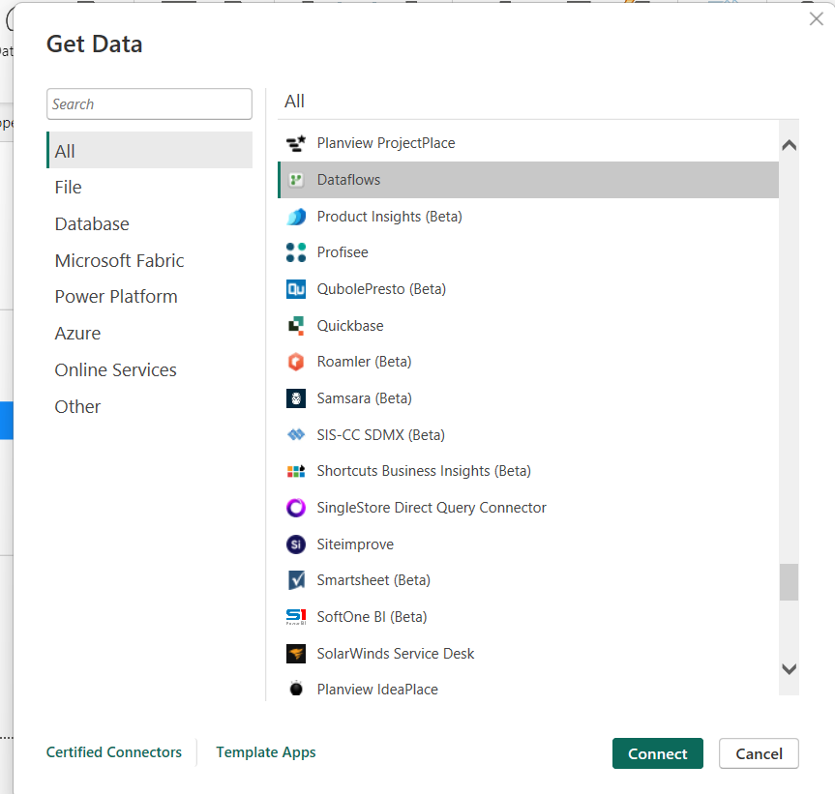
Steps:
- Go to the Power BI Service (app.powerbi.com).
- In your workspace, create a Dataflow by clicking on Create > Dataflow.
- In the dataflow, you can connect to various data sources (e.g., Excel, SQL Server, SharePoint), and apply the same transformations you did in Power Query in Power BI Desktop.
- Once the dataflow is created and the transformations are saved, you can use the dataflow as a data source in Power BI Desktop.
4. Using Upstream Data in Power BI Desktop:
If you’ve created a dataflow in Power BI Service and want to use it in Power BI Desktop:
- Open Power BI Desktop.
- Click Get Data > Power BI Dataflows.
- Sign in to your Power BI Service account and select the workspace that contains your dataflow.
- Select the dataflow and load the data (the transformed data is now ready for use).
- Downstream in power bi
Key Steps in Downstream Data Handling in Power BI
- Load Transformed Data (Upstream) into Power BI Model: After performing upstream transformations (either in Power Query or Power BI Dataflows), you load the transformed data into the Power BI model. This is the first step in downstream, as now your clean data is ready for analysis and reporting.
- Data Modeling: Once the data is loaded into Power BI, you may need to create relationships between tables, add calculated columns and measures, and build a data model that supports your analytical needs. This is the heart of the downstream process.
Steps:
  - Create Relationships: Use the Model view to establish relationships between tables (e.g., linking Sales table with a Products table through a ProductID).
  - Calculated Columns and Measures: You may add calculated columns (for instance, Profit = SalesAmount - Cost) or measures (e.g., Total Sales = SUM(Sales[SalesAmount])).
- Create Visualizations: In this downstream stage, you will use the data model to create visual reports and dashboards. Power BI provides a wide range of visualization options to help you display your data insights.
Steps:
  - Select Data Fields: Drag and drop fields from your model onto the report canvas.
  - Choose Visual Types: Create different types of visuals (bar charts, line charts, tables, etc.) based on the insights you want to show.
  - Customize Visuals: Format the visuals (colors, axis labels, titles, etc.) to make them more readable and insightful.
- Create Measures for Advanced Analytics: In addition to basic calculations, you can create more complex DAX measures to handle more advanced scenarios. Measures can be used to calculate aggregates, averages, percentages, year-over-year growth, etc.

Power bi related Microsoft tools: -
It looks like you meant Power BI related Microsoft tools. There are several tools and services within the Microsoft ecosystem that complement Power BI:
- Azure Data Factory: Used for data integration and orchestration, it helps move data between different data sources and Power BI.
- Power Automate: Automates workflows between your apps and services to synchronize files, get notifications, collect data, and more, often in conjunction with Power BI.
- Power Apps: Allows you to build custom apps with Power BI visualizations embedded in them.
- Azure Synapse Analytics: Integrates with Power BI to handle large-scale data processing and advanced analytics.
- Excel: Integrates seamlessly with Power BI, allowing you to import and visualize Excel data.
- SharePoint: You can embed Power BI reports into SharePoint Online for broader access and sharing.
- Microsoft Teams: Embed Power BI reports and dashboards in Teams for collaborative analysis and decision-making.

